Biennial Report – “Alcohol, Tabaco and other Drugs” (ATOD) Prevention Program
Inter-American University of Puerto Rico
School of Law
January, 2013 – December, 2014

Introduction
This report reviews the actions taken at the School of Law of the Inter-American University of Puerto Rico to comply with the Education Department General Administrative Regulations (EDGAR) Part 86 during the time period from January, 2013 to December, 2014. Specific attention was given to the recommendations presented in the previous report of 2011 – 2012. This biennial report contains the following:
- Brief description of the elements of the ATOD prevention program (ATOD-PP);
- ATOD-PP goals and assessment of goal achievement; and,
- Recommendations for improvement of the ATOD-PP.
ATOD-PP at the School of Law – IAU of PR
The School of Law of the Inter American University of Puerto Rico is an urban campus in San Juan, Puerto Rico, dedicated to in the training of future lawyers. Its administrative staff, full and part time, consists of approximately 110 persons and its full time faculty comprises 37 professors. Between January, 2013 and December, 2014, its student body fluctuated between 735 and 850 students. Table1 provides a breakdown of the following demographic variables of the student population at the Law School for time frame of this biennial report: sex, section (Day and Night) and the average age (years) of the student population at the Law School throughout time frame of this biennial report.
Table 1. Demographic data of students distributed under the following variables: semester, total student body, sex, section and median age in years (average) of the student population during 2013-2014.
Semester | Student Body | Sex |  | Section |  | Age (Average)
 |  | Female | Male | Day | Night
Jan-May, 2013 | 735 | 399  54.29% | 336  45.71% | 379  51.56% | 356  48.44% | 33
Agst-Dic, 2013 | 809 | 453  56.00% | 356  44.00% | 380  46.97% | 429  53.03% | 32
Jan-May, 2014 | 791 | 435  54.99% | 356  45.01% | 369  46.65% | 422  53.35% | 32
Agst-Dic, 2014 | 850 | 486  57.18% | 364  42.82% | 399  46.94% | 451  53.06% | 31
Information provided by SWBYAUTO, report from Banner

On May 11, 2011, the Dean of the Law School, Doctor Luis Mariano Negrón Portillo, designated the Dean of Academics, the Dean of Students, the Director of Human Resources and the Chaplain as a permanent committee with the mission of keeping the milieu of the campus within the spirit of the Education Department General Administrative Regulations (EDGAR) Part 86 (from now on, Alcohol, Tabaco and other Drugs – Prevention Committee or ATOD-PC). On March 21, 2013, Doctor Julio Fontanet Maldonado officially became the Dean of the Law School and has maintained the composition of the ATOD-PC as designated by his predecessor: the Chaplain, Doctor Luis Borri Díaz, as the coordinator, the Dean of Academics, Doctor Yanira Reyes Gil, the Dean of Students, Doctor Iris Camacho Melendez and the Director of Human Resources, Mrs. Milagros Pérez de Amalbert.
This biennial report (2013 – 2014) is based on the seven recommendations of the previous report (2011 – 2012) grouped under the following three headings:
- Renovation of membership and participation in the “Consorcio de Recursos Universitarios Sembrando Alianza de Alerta a las Drogas, el Alcohol y la Violencia” (CRUSADA);
- Notification of students, teaching and non-teaching staff about university’s drug, alcohol, tobacco policies and the policies concerning violence related issues within the campus;
- Incorporation of the Student Council as a collaborator in the mission of this committee.

ATOD-PP Goals and Assessment
The ATOD-PC of the Inter American University School of Law was established in the summer of 2011 with the mission of keeping the milieu of the campus within the spirit of the Education Department General Administrative Regulations (EDGAR) Part 86. This committee established three goals:
- Renovation of membership and participation in the “Consorcio de Recursos Universitarios Sembrando Alianza de Alerta a las Drogas, el Alcohol y la Violencia” (CRUSADA)
Since its foundation on 1989, CRUSADA, a consortium of colleges and university campuses (private and public) of Puerto Rico, has been committed in sustaining a healthy social environment within the colleges and university campuses by way of promoting lifestyles free of alcohol and other drugs and violence. It has received the backing of the “Network Addressing Collegiate Alcohol and Other Drug Issues” of the Department of Education of the federal government. Within every biennial period and in collaboration with CORE Institute (the largest Alcohol, Tabaco and Other Drugs database about college student’s drinking and drug use in U.S.A.), CRUSADA coordinates a survey about risky behavior related to alcohol and other drugs among college students. However, each college campus is responsible for the administration of the survey.
Since the fall of 2011, the School of Law has been an official member of CRUSADA. Doctor Borri Díaz has consistently participated in CRUSADA’s monthly meetings and has collaborated in “Congreso de CRUSADA”, an annual event aimed to keep the top ranking higher education administrators and student service providers informed on the various issues concerning drugs and violence within and around college campuses. Also, this event is an opportunity for the ongoing formation of leadership among those students committed to CRUSADA’s mission.
On April, 2013, the Law School participated for the first time in CRUSADA’s survey. Previous to its administration, a random stratified sample was selected from the compulsory courses: first, second, third and four year courses. On paper, the sample consisted of eleven courses with a total amount of 418 students (56.87% of the student population for that semester). Previous to its administration, the professors agreed to provide the last 10 minutes of their class period. Once concluded with the informed consent protocol, the administrator distributed the survey among those who decided to participate. Most participants consumed approximately 15 minutes to answer the survey. Some students verbalized that they did not participate or finish the survey due to the time constraint between classes.
Upon concluding its administration, a total amount of 182 surveys were mailed to the CORE Institute for tabulation and interpretation. CORE’s interpretation was finally received on December 12, 2013.
Table 2 presents similar information as Table 1 but in terms of the participants of the survey. Nineteen participants did not identify their sex and thirteen participants did not report a section. Under the variable “age”, the calculated average age in years of the participants was 31 (rounded).
Table 2. Demographic data of participants distributed under the following variables: semester, total student body, sex, section and average age (years) of students
 |  | Sex* |  | Section**
 | Total | Female | Male | Day | Night | Age (Average)
CRUSADA SURVEY 2013 | 182 | 79  48.47% | 84  51.53% | 94  55.62% | 75  44.38% | 30.94
* 19 participants did not respond this item; hence percentage calculation based on 163. |  |  |  | ** 13 participants did not answer this item; hence percentage calculation based on 169

In Table 3, the variable “age” was organized in the following groups: 22-25, 26-30, 31-35, 36-40, 41-45, 46-50 and 50 plus. Twenty one participants did not identify their age. Most participants were 26 years old or above and 67.59% of the participants were between 22 and 35 years old.
Table 3. Age-Groups of participants
Ages (years) | Frequency | Percent
22-25 | 44 | 24.18%
26-30 | 54 | 29.67%
31-35 | 25 | 13.74%
36-40 | 18 | 9.89%
41-45 | 10 | 5.49%
46-50 | 5 | 2.75%
51+ | 5 | 2.75%
Missing | 21 | 11.54%
Total | 182 | 100.0%

In the meeting of June 27, 2013, the members of committee reviewed the items of the survey and the process used for its administration. In a round table discussion, various members of the committee agreed that the survey was more consistent with the experience of college students than with the experience of law students. However, the committee pointed out that content some items did have relevance within the context of our Law School.
Table 4. Items of most pertinence and their themes
Items |  | Theme/Topic
4,5,6, 7, 8, 9, 10 |  | Consumption
15, 16 |  | Risk behavior
17, 18, 19, 20 |  | Security and violence
25, 34 |  | Help
26, 27, 28, 29 |  | Reasons for consumption
32, 33 |  | Suicide

Additionally, the tradeoff between the thoroughness of the survey and the time required for its completion is a factor to take into account in future administrations.
In the meetings of January 30, and of July 18 of 2014, the ATOD-PC reviewed the results of the survey, including the executive summary as prepared by staff of the CORE Institute. On the first meeting, the committee raised two main concerns: first, how to incorporate the students in the analysis of the survey and second, how to integrate prevention consciousness in the curriculum of the Law School. These two points will be briefly elaborated later on in this report.
Assessment. The School of Law has maintained its presence in CRUSADA which has entailed its timely membership payment and all other fees, as for example, CRUSADA’s annual conference. In April, 2013, the School of Law participated for the first time in CRUSADA’s survey. During the biennial of 2013-2014, the committee met on three occasions to attend different issues concerning the survey.
Recommendations:
- The committee recommends that the School of Law maintains its present participation in CRUSADA;
- The committee should consider two meetings per semester so it can follow up on its projects.

- Follow up on the methods used to notify the students, the teaching and non-teaching staff about university’s drug, alcohol, tobacco policies and the policies concerning violence related issues within the campus.
At the School of Law, the practice of the distribution of the institutional policies, including those of ATOD and violence issues, has been limited to new students and new teaching and non-teaching personnel. Originally this material was presented on a paper format. However, since August, 2006 the new students began receiving this information in a paperless format. This has been done in the following fashion. All new law students must participate in an in-house seminar as an introductory experience to the study of law. At the beginning of this seminar, all receive a compact disk (CD) containing an electronic version of the School of Law catalogue, the Student Regulations, and all the institutional policies, including those related to ATOD and violence issues. Each student signs a document acknowledging the receipt of the CD. (See Addenda 1 through 4)
As a standard practice, the Dean of Students meets at the beginning of the fall and spring semesters with the representatives of the Student Council and of official student associations. Part of the agenda for this meeting includes the remainder of the institutional policies concerning ATOD and violence issue within the campus.
Only new employees receive the university’s drug, alcohol, tobacco policies and the policies concerning violence related issues within the campus. Originally this information was presented on a paper format, but since 2012, this changed to a CD format. The employee signs a receipt which is properly filed in the personnel record system at the office of Human Resources of the School of Law.
Additionally, all institutional policies are posted at the university’s web page (http://documentos.inter.edu/docs/) and thus available on a 24/7 basis.
The institutional ATOD and violence policies contain and describe the following:
- Standards of conduct that prohibit unlawful possession, use, or distribution of illicit drugs and alcohol on its property or as part of its activities;
- A description of the health risks associated with the use of illicit drugs and the abuse of alcohol;
- A description of applicable legal sanctions under local, state or federal law;
- A description of applicable counseling, treatment or rehabilitation or re-entry programs;
- A clear statement of the disciplinary sanctions the institution will impose on students and employees, and a description of those actions.
One of the recommendations of the previous biennial report was as follows: For the period of 2013 – 2014, include workshops or similar activities for students on ethical issues on ATOD risk behavior and the access to the practice of the legal profession. As a way to implement this recommendation, on February 4, 2014, the committee organized a conference/workshop, titled Impacto del uso de drogas y alcohol en la admisión y práctica de la abogacía (Alcohol and Drug Consumption and its Consequences for Admition to the Bar and the Practice of Law). The Student Council sponsored this activity. And although targeted for students, it was open to teaching and non-teaching personal. The resources were: Professor Ángel Candelario, and Evelyn López Carrión y Adela Rivera as representatives of the Administración de Salud Mental y Contra la Adicción (ASSMCA) [Administration for Mental Health and Drug Prevention].
The Dean of Studies, Doctor Yanira Reyes Gil, has approached the professors of the courses of ethical legal practice in order to integrate issues on ATOD risk behavior and its effects on the practice of the legal profession.
Additionally, the preparatory seminar for the study of law integrates a discussion on the requirements for the bar exam. To comply with one of these requirements, the candidates for the bar exam must provide information on any previous problems with the use of alcohol and drugs. For this reason, the discussion comprises the analysis of the different patterns of behavior that impacts the moral character expected from those in the legal profession.

Assessment. Every new student of the entrance classes of January, 2013, August, 2013, January, 2014 and August, 2014 has received the information referred on the previous section.
- See Appendix A for the documentation on the distribution of institutional policies to entrance class of January, 2013;
- See Appendix B for the documentation on the distribution of institutional policies to entrance class of August, 2013;
- See Appendix C for the documentation on the distribution of institutional policies to entrance class of January, 2014;
- See Appendix D for the documentation on the distribution of institutional policies to entrance class of August, 2014;
- See Appendix E for the documentation on the conference/workshop: Impacto del uso de drogas y alcohol en la admisión y práctica de la abogacía, February 4, 2014.
The Office of Human Resources (OHR) organized various activities on the issues related to the different institutional policies, including ATOD policies. For this biennial time period, the OHR gave emphasis to the theme of “stress management”, as shown in Appendix F.
Recommendations:
- Continue with the practice of the distribution of the institutional policies, including those of ATOD and violence issues to the new students as previously described. The distribution plan can be complemented by a mass e-mail system to remind all students and all staff (teaching and non-teaching) that all institutional policies are posted on the university’s web site http://documentos.inter.edu/docs/index.php?category=5www.bpahealth.com and by posting on the web home page of School of Law a link to the ATOD and violence policies.
  - Continue to search for ways to integrate in the curricula of the School of Law the issues on ATOD risk behavior and its effects on the practice of the legal profession.
  - Arrange a conference for faculty and students on health and legal consequences of the illegal use of legal drugs as adderall.
  - Integrate ATOD information within the introductory seminar as required for all new students.
  - Include in future biennial reports information on the institutional investment made on security equipment during the corresponding period.
- Search and implement ways to incorporate the First Aid Office as a collaborator in the mission of the ATOD-PC.

- Search and implement ways to incorporate the Student Council as a collaborator in the mission of ATOD-PC.
On the previous biennial report, the Committee made two recommendations under this heading: first, “search and implement ways to incorporate the various students’ associations as collaborators in the mission of the ATOD-PC” and second, “design learning experiences for our law students within the context of the institutions that provide shelter to victims of violence”.
The Student Counsel collaborated in the promotion of the conference/workshop: Impacto del uso de drogas y alcohol en la admisión y práctica de la abogacía (Alcohol and Drug Consumption and its Consequences for the Admition to the Bar and the Practice of Law), February 4, 2014.
On February 28, 2014, the Chaplain and the Dean of Students meet with the Student Council to review the purpose and the reasons behind the survey and to discuss the results of the survey, particularly those related to alcohol and drug consumption and the emotional health of the participants.
From the 6th to the 16th of November, 2014, professors and law students collaborated in a project using the platform of Facebook to raise consciousness against gender violence. The Instituto de Estudios sobre Mujeres, Género y Derecho (Inter-Mujeres), (Institute for the Study of Women, Gender and Law) and the Organización de Mujeres Esudiantes de Derecho (Organization of Female Law Students) encouraged people, particularly young people, to take a public stand denouncing gender violence. Participation consisted in posting on the Facebook page of Inter-Mujeres a photo of oneself with a sign stating “I am against gender violence”. According to the statistical data generated by the Facebook platform, a total of 9,172 persons viewed this particular page and 1,628 viewers interacted with its content in one way or another.
Concerning the second recommendation, the Dean of Students approached various institutions that provide shelter to victims of violence. However the protection of victim of violence requires that any learning experience for our law students must meet safety and confidentiality considerations acceptable for the shelters providing protection and for our institution. This criterion has been a challenge and the committee should approach the Law Clinic as an alternative.
Assessment. Students have participated in different activities that are consistent with the mission of the ATOD-PC. One of these activities integrated the participation of law professors and our students.
Recommendations:
- To institutionalize the membership of a student in the ADO-PC, as for the example, the President or Vice-president of the Student Counsel.
- Explore effective ways to encourage our law students to enroll in the different programs through which the Law Clinic provides assistance to victims of violence.

ATOD-PP Strengths and Weaknesses
The ATOD-PP at the School of Law Campus complies with the federal law and meets the institution’s ethical obligations to keep students and employees informed about the consequences of substance abuse. Initial steps have been taken to incorporate prevention consciousness in our curricular structure, as for example, the integration of prevention information in our in-house seminar as required for all new students, and the initial approach of the Dean of Academics to some of our professors.
Although students have participated in different activities that are consistent with the mission of the ATOD-PC, there is no permanent student representation in committee.
As mentioned in the previous biennial report, the Law School does not have an in-house counseling or psychological resources to deal with substance abuse behavior. However it can make available the basic information on the various centers within the San Juan Metropolitan area that do provide such services. This should be one of the goals for the upcoming biennial unit.

The Coordinator of the ATOP-PC prepared and presented this report to the members of the committee for their approval on April 20, 2015.

ATOD-PC members:
Doctor Yanira Reyes Gil, Dean of Academic Affairs
Doctor Iris Camacho Meléndez, Dean of Students
Mrs. Milagros Amalbert, Director of Human Resources
Doctor Luis Antonio Borri Díaz, Chaplain

Appendix A
Entrance Class – January, 2013
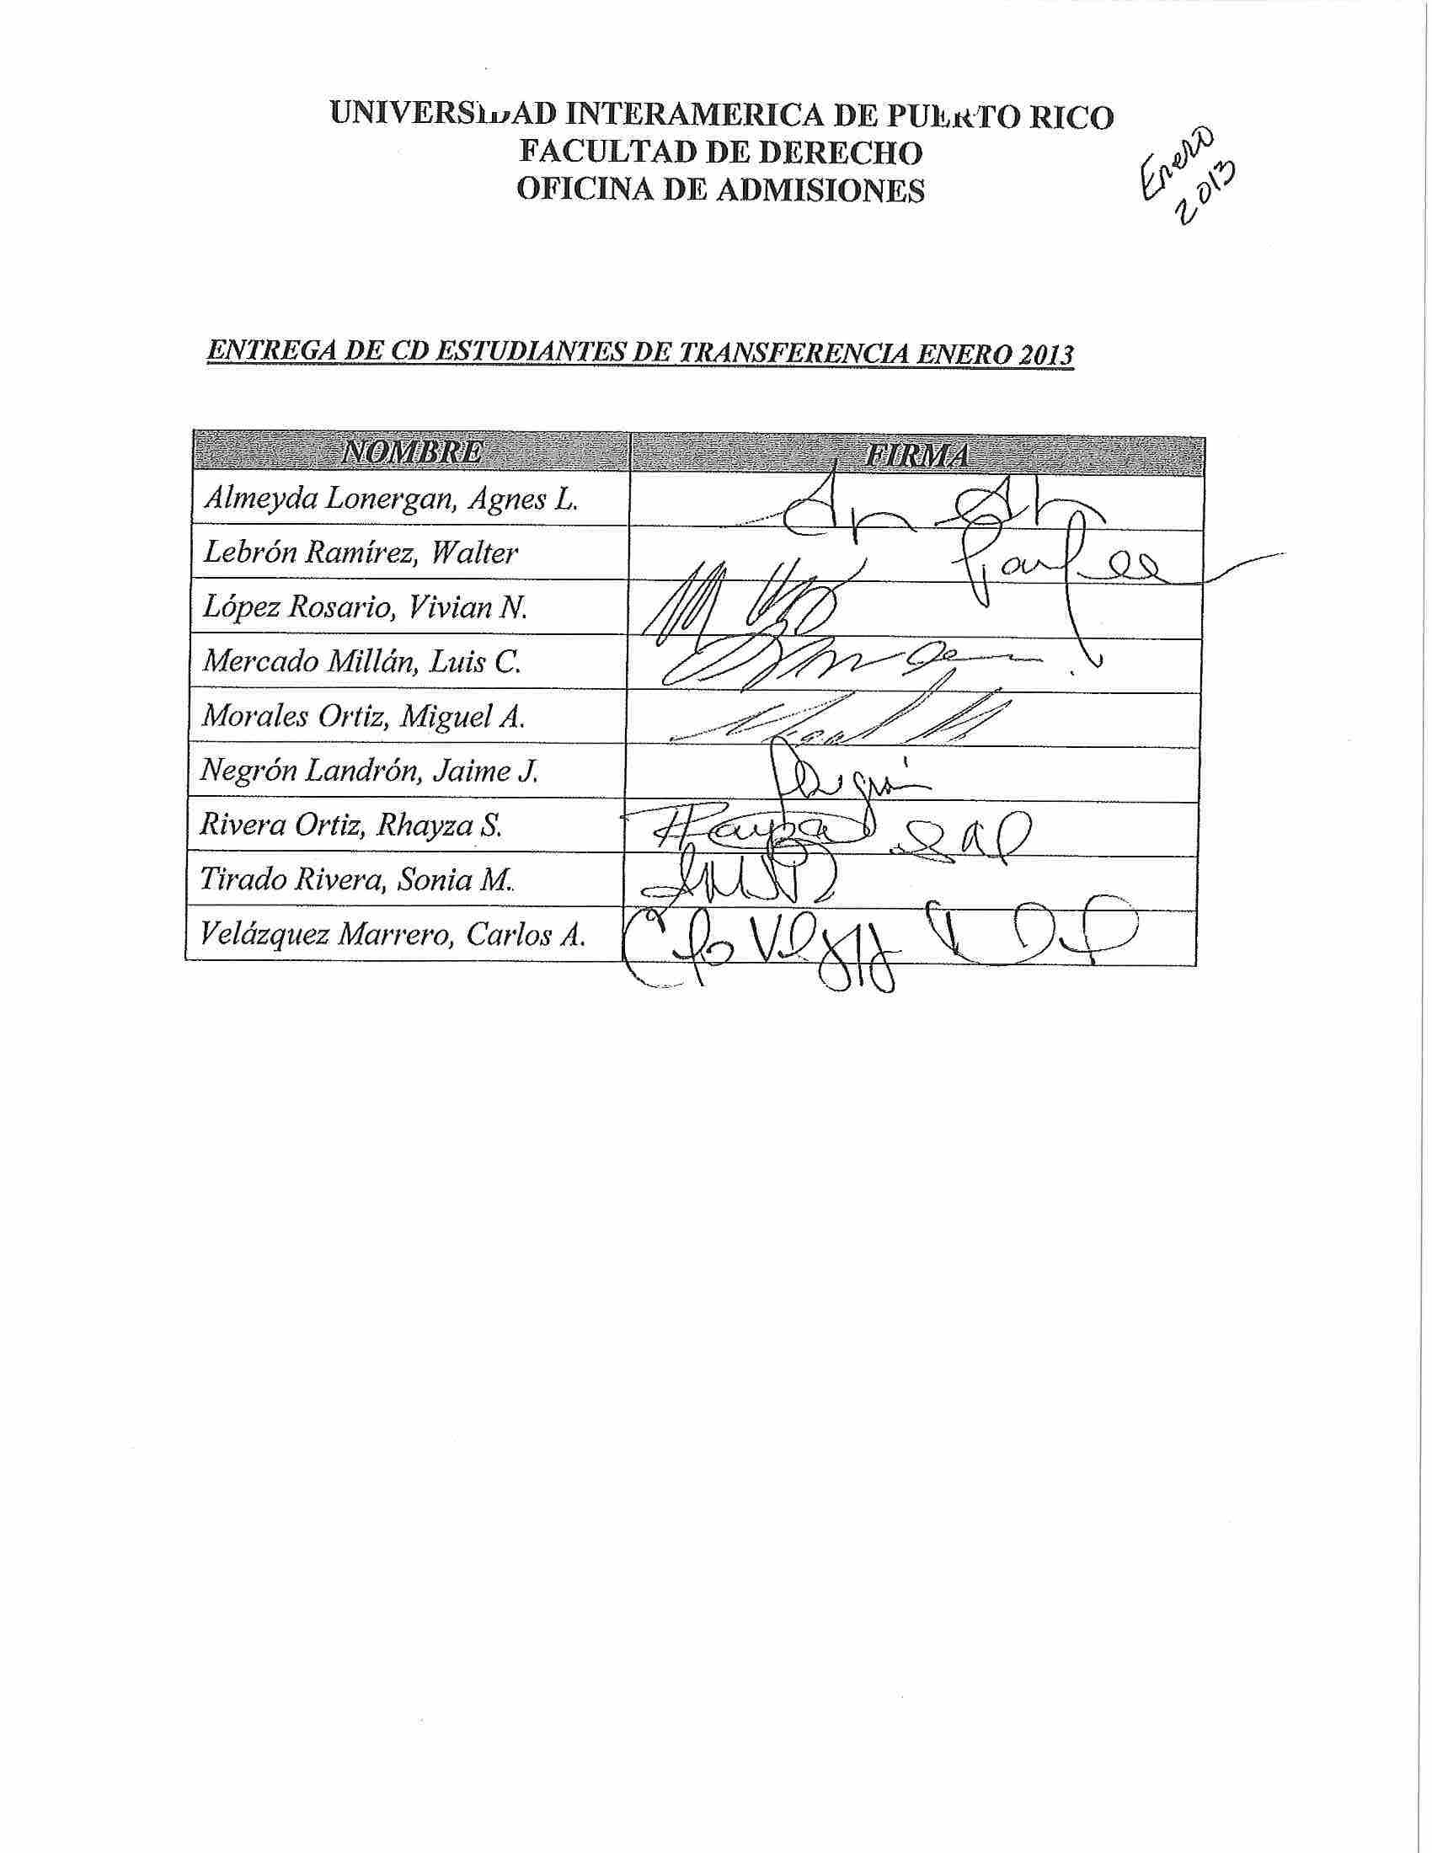
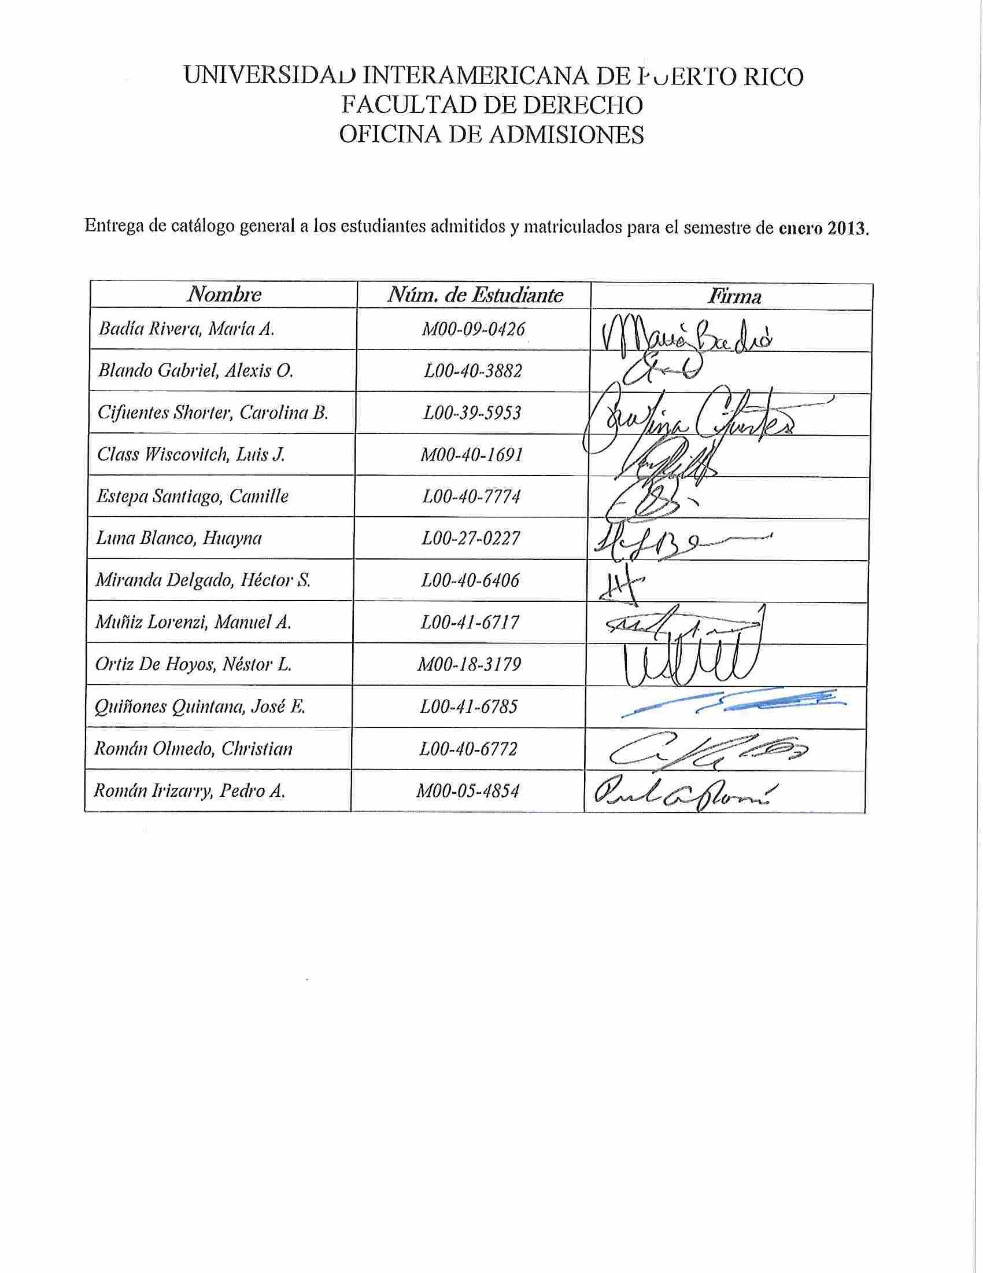

Appendix B
Entrance Class – August, 2013
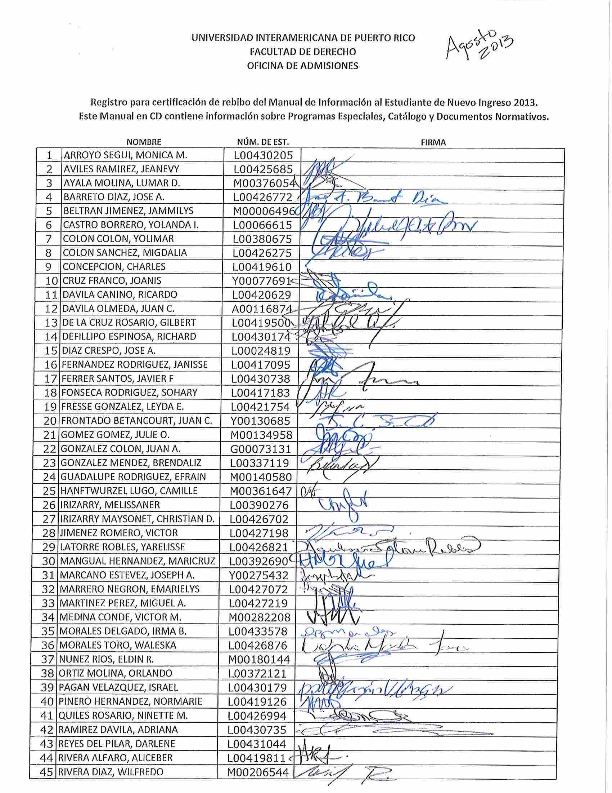
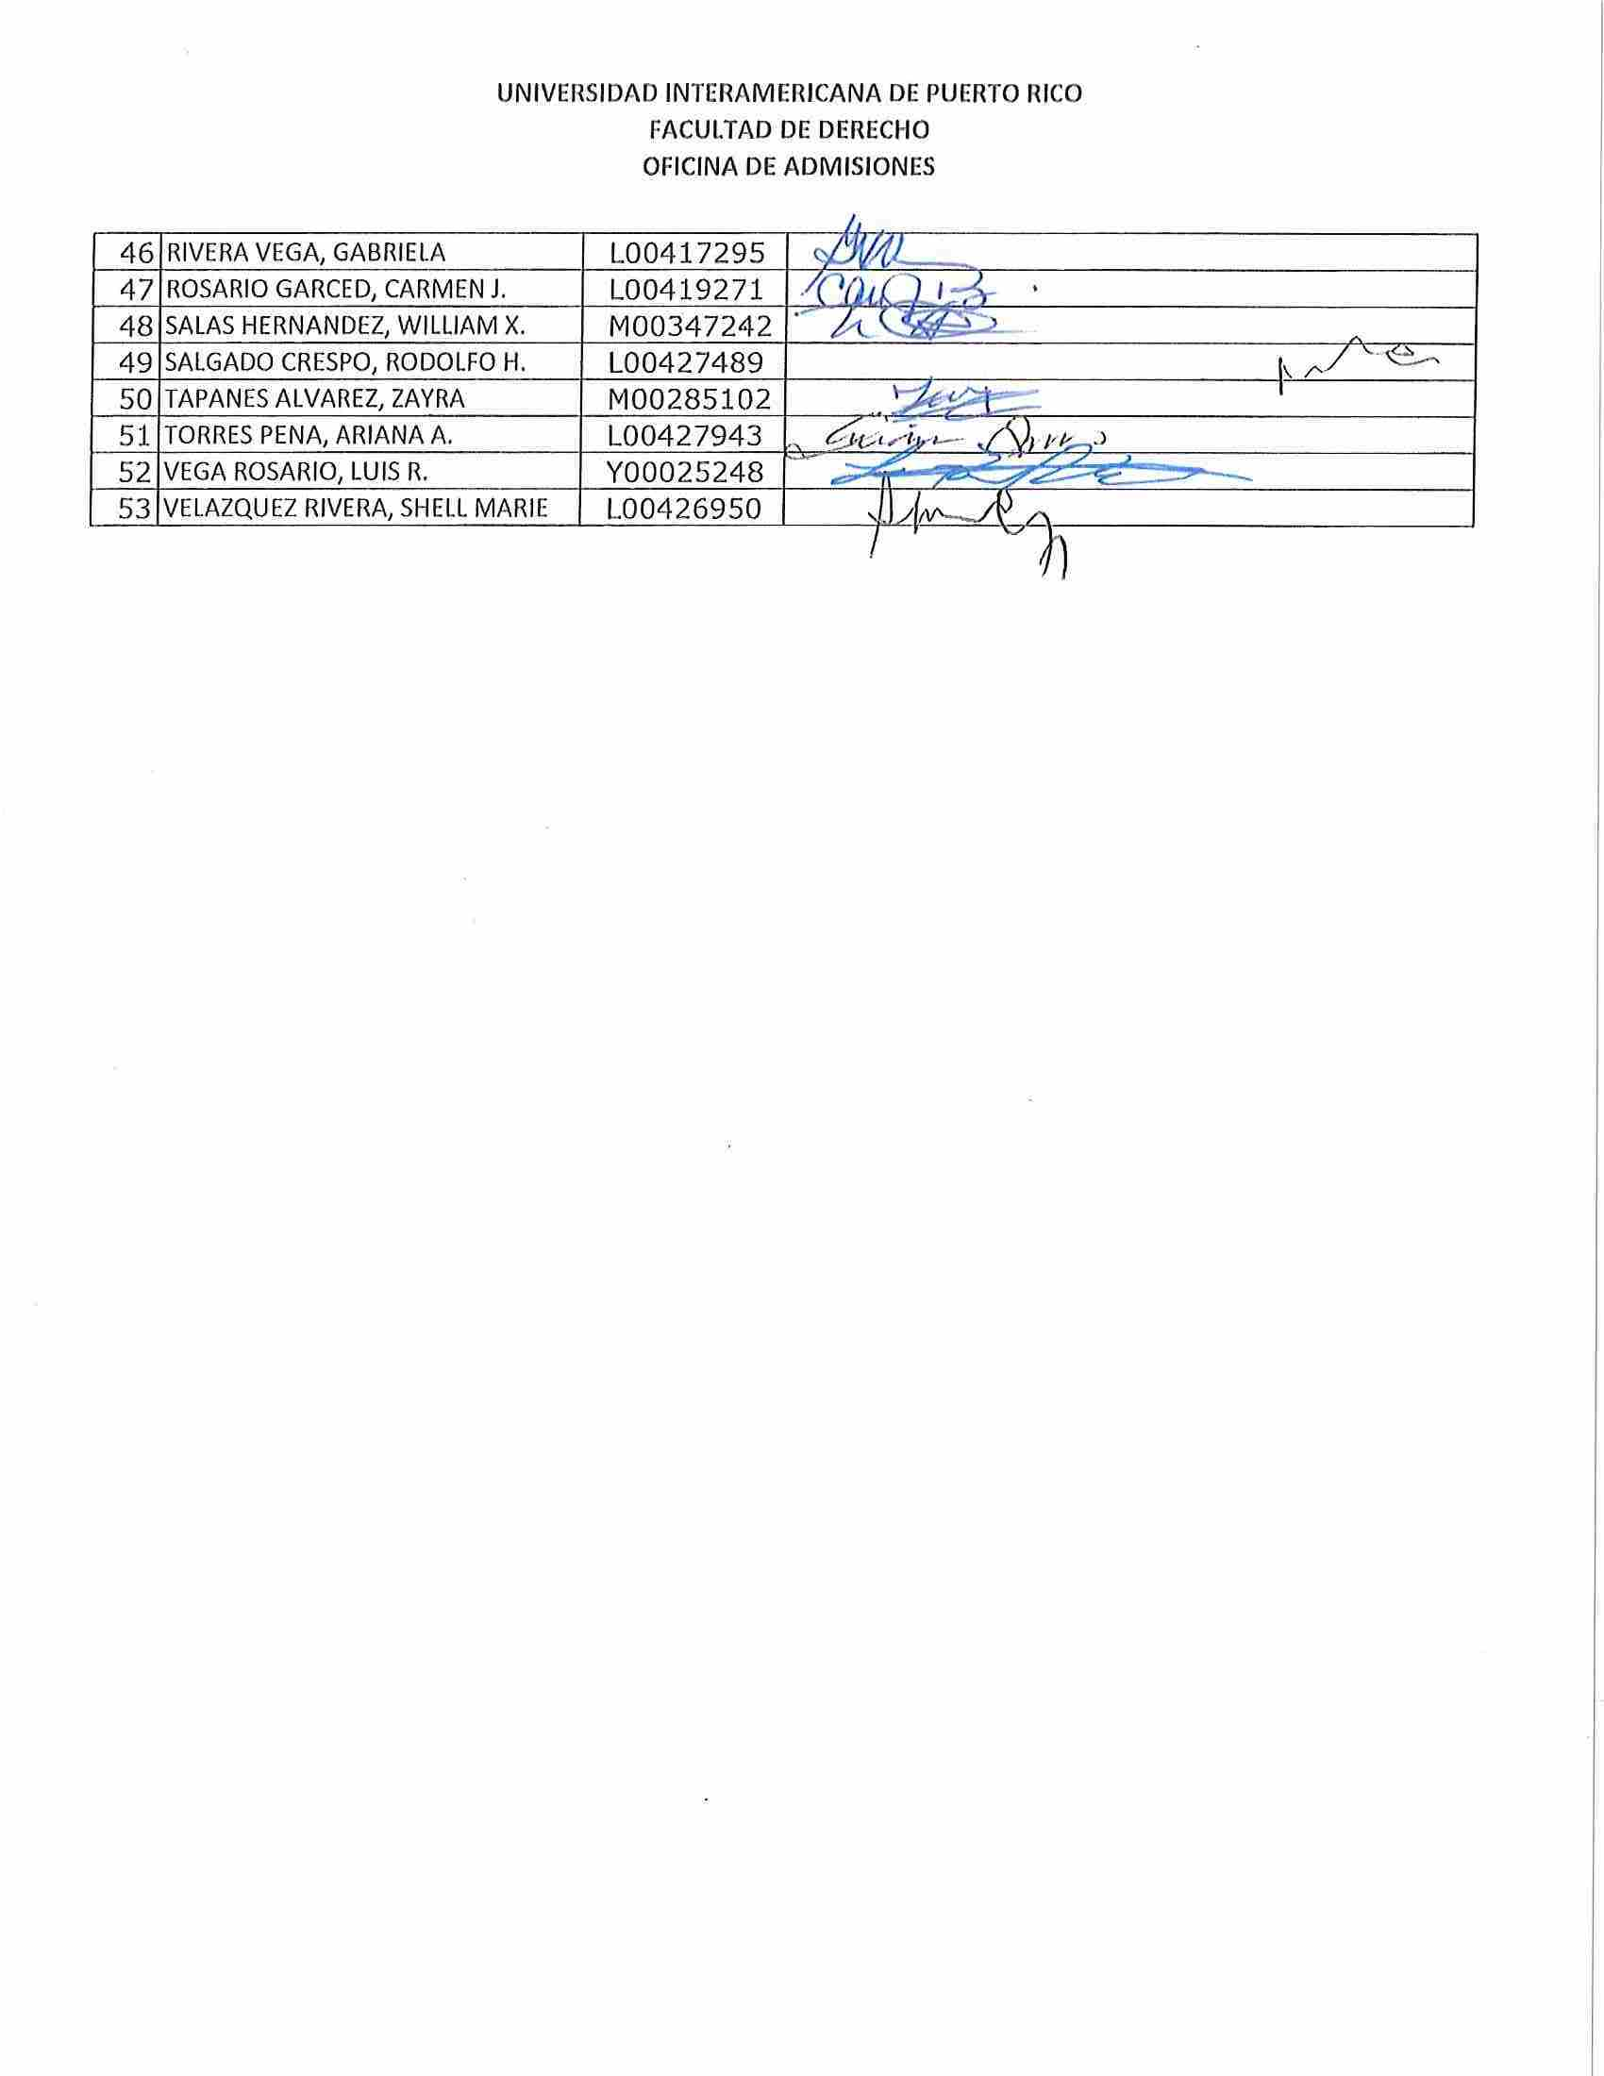
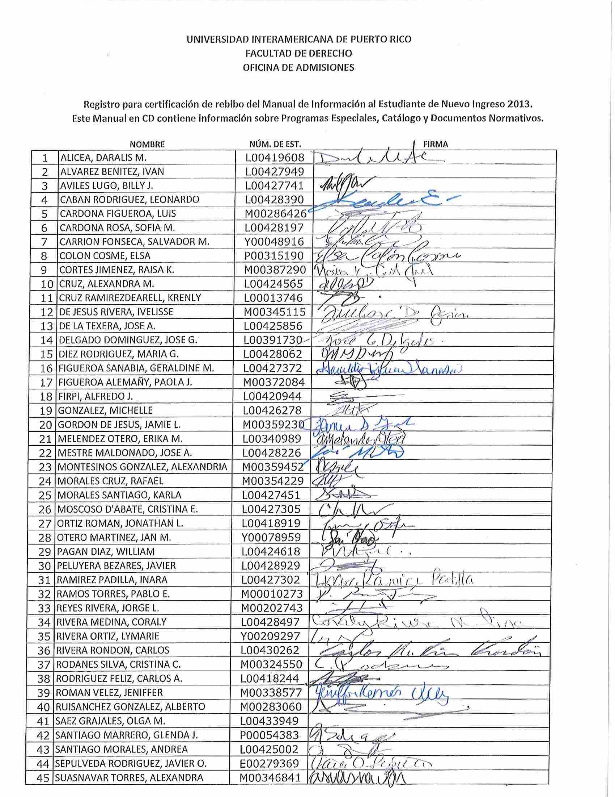
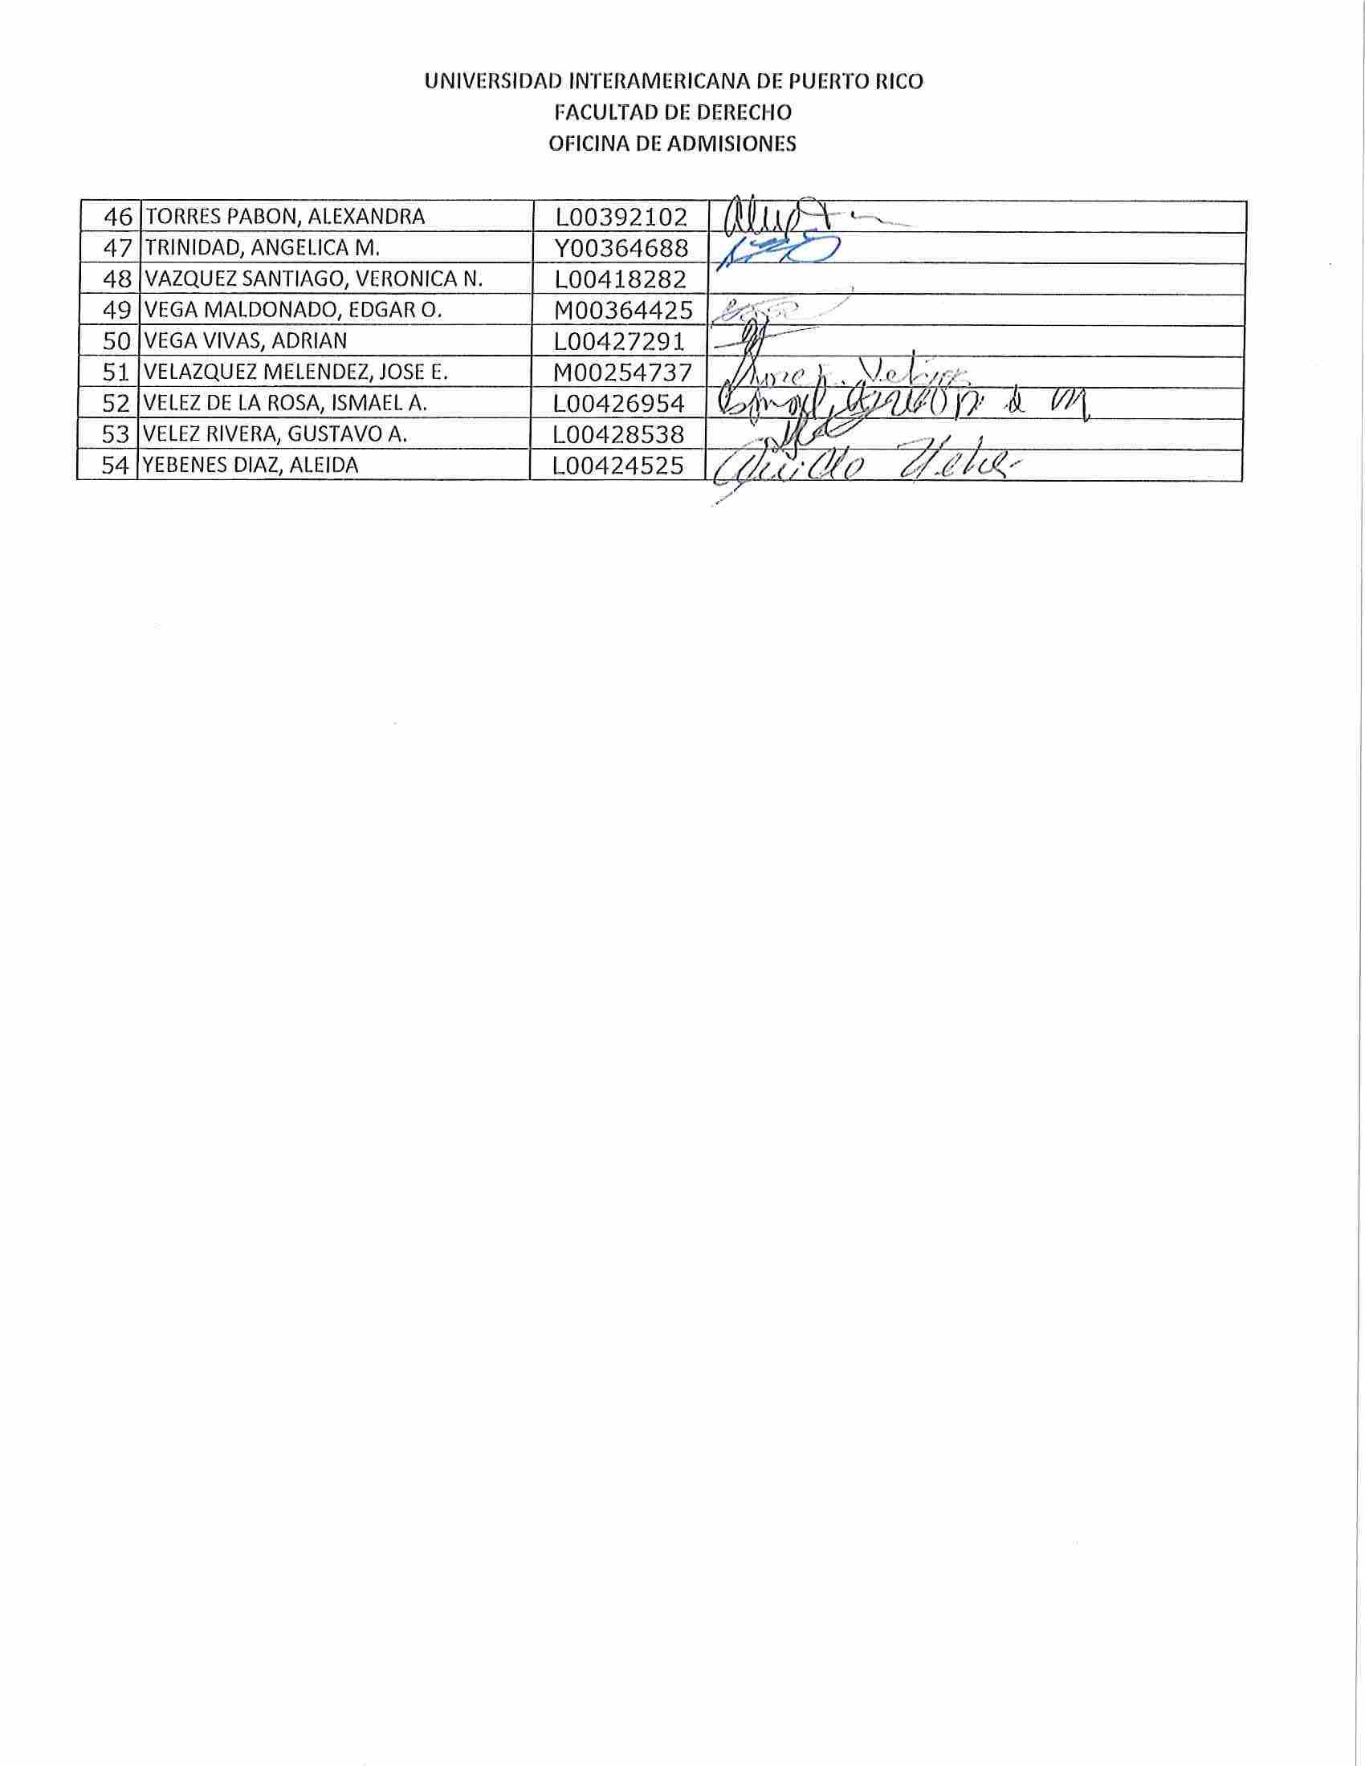
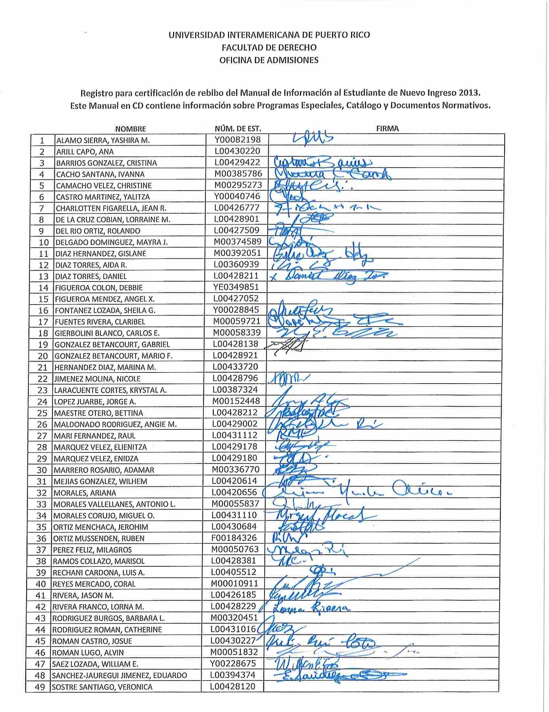
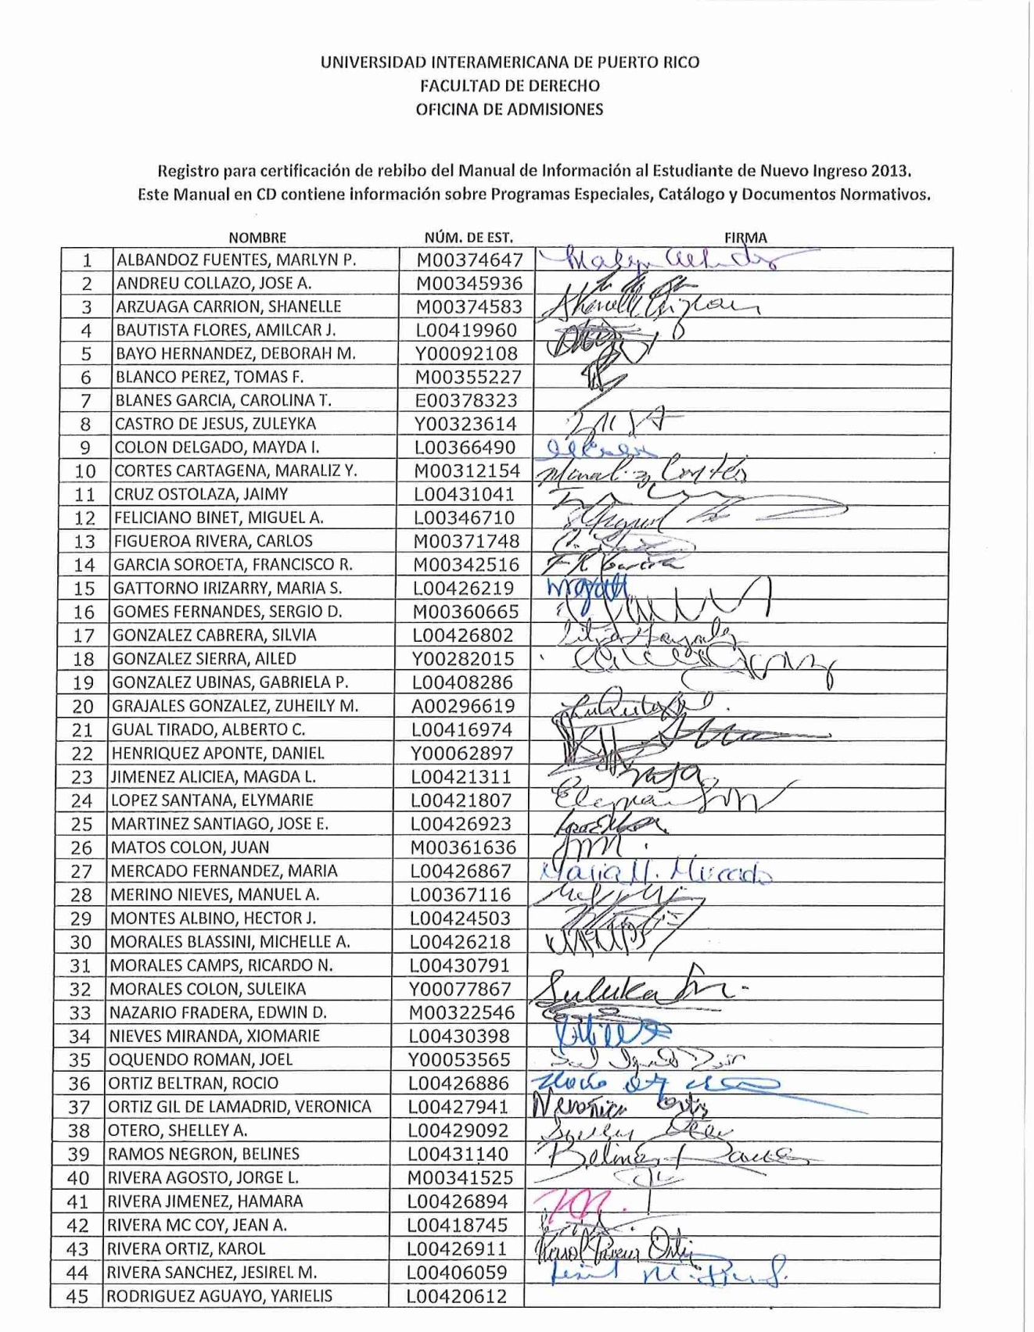
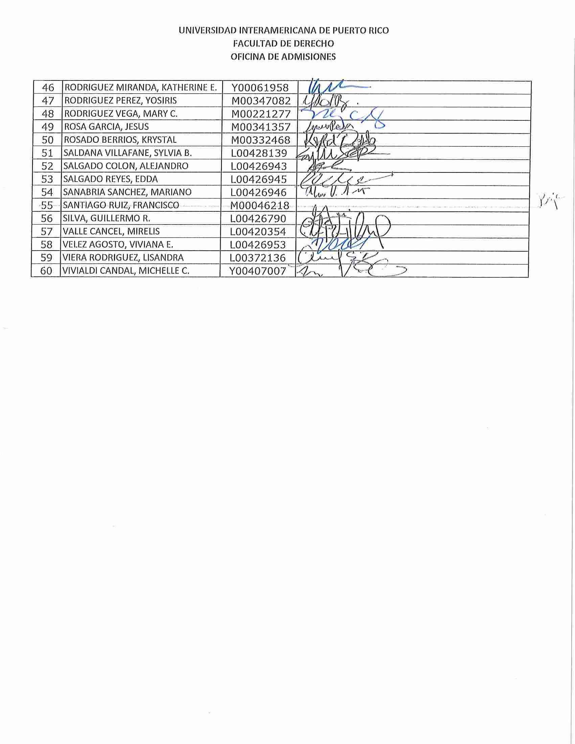

Appendix C
Entrance Class – January, 2014
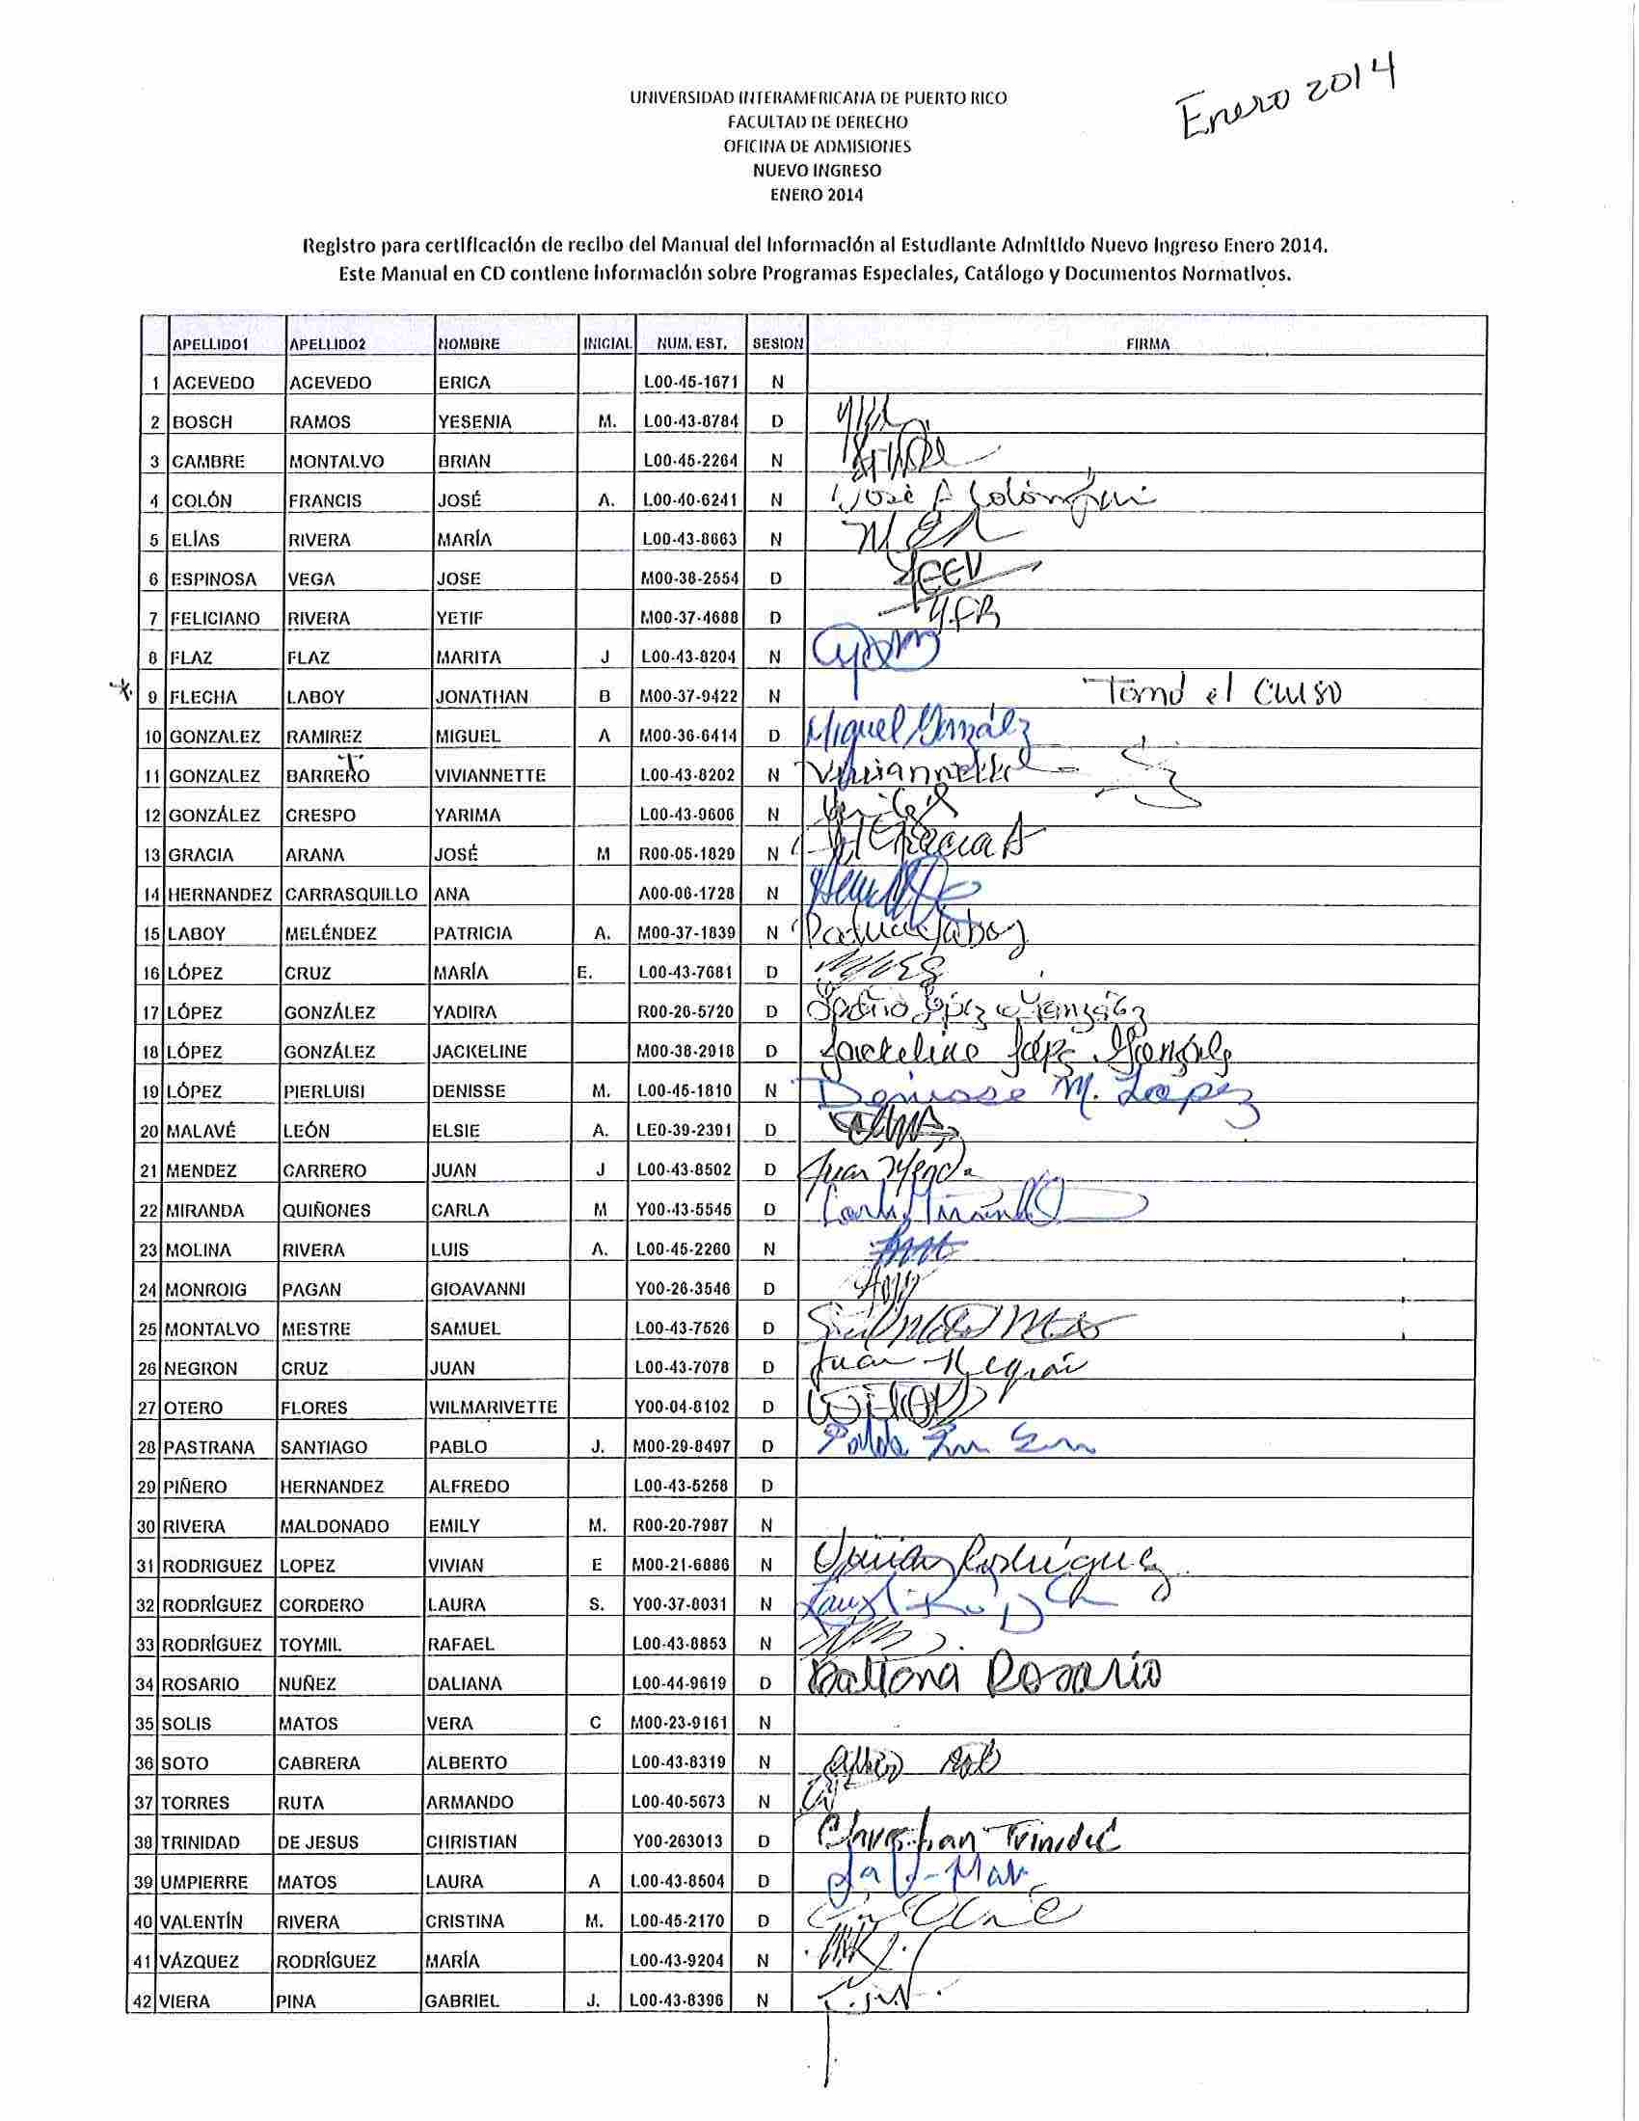

Appendix D
Entrance Class – August, 2014
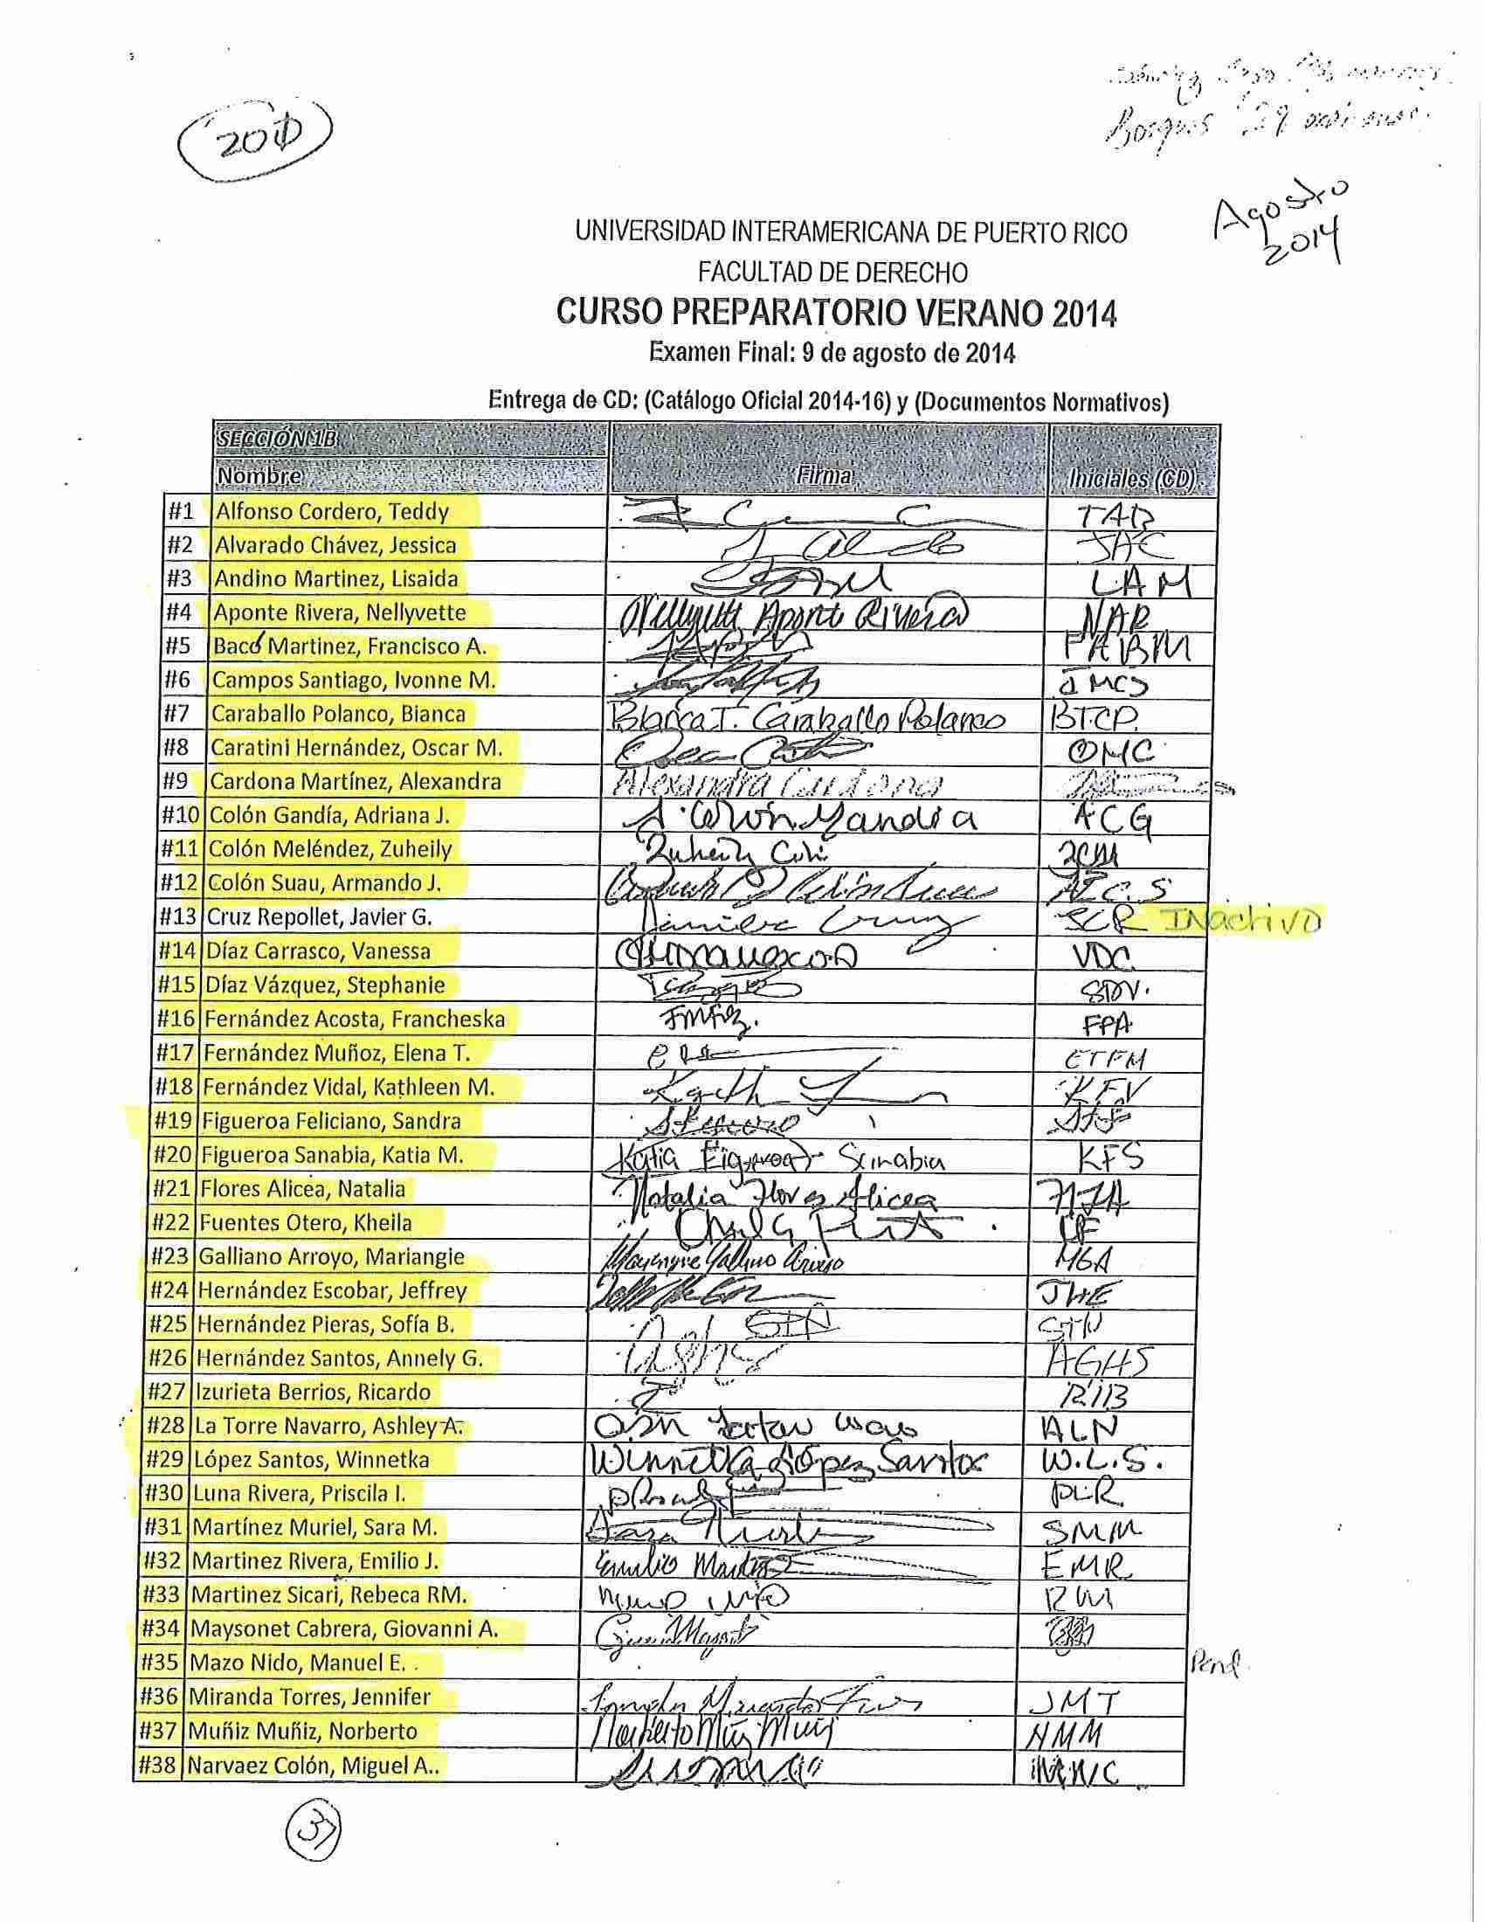
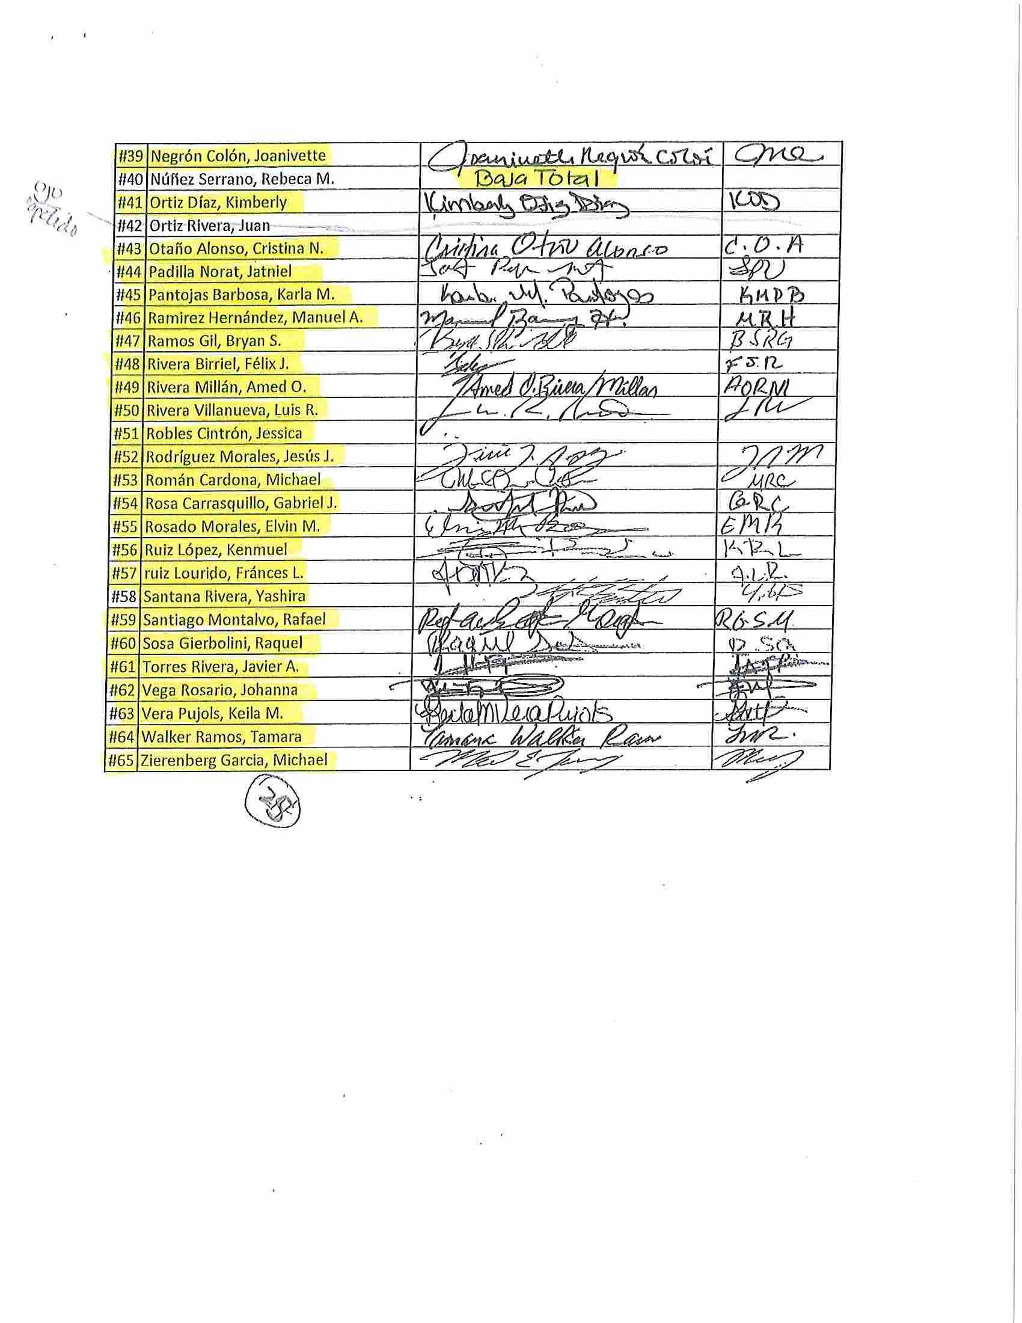
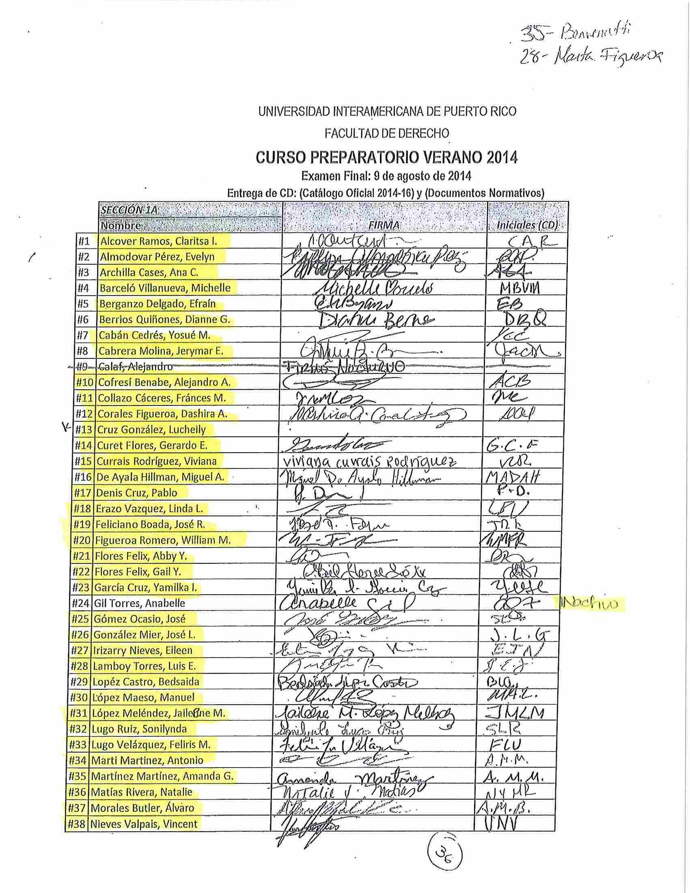
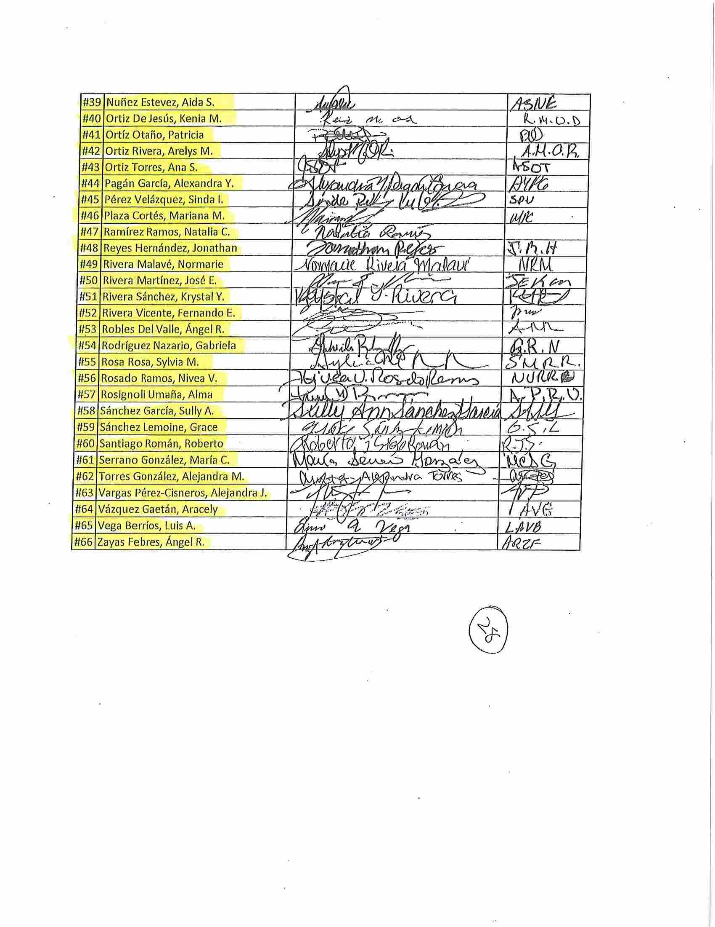
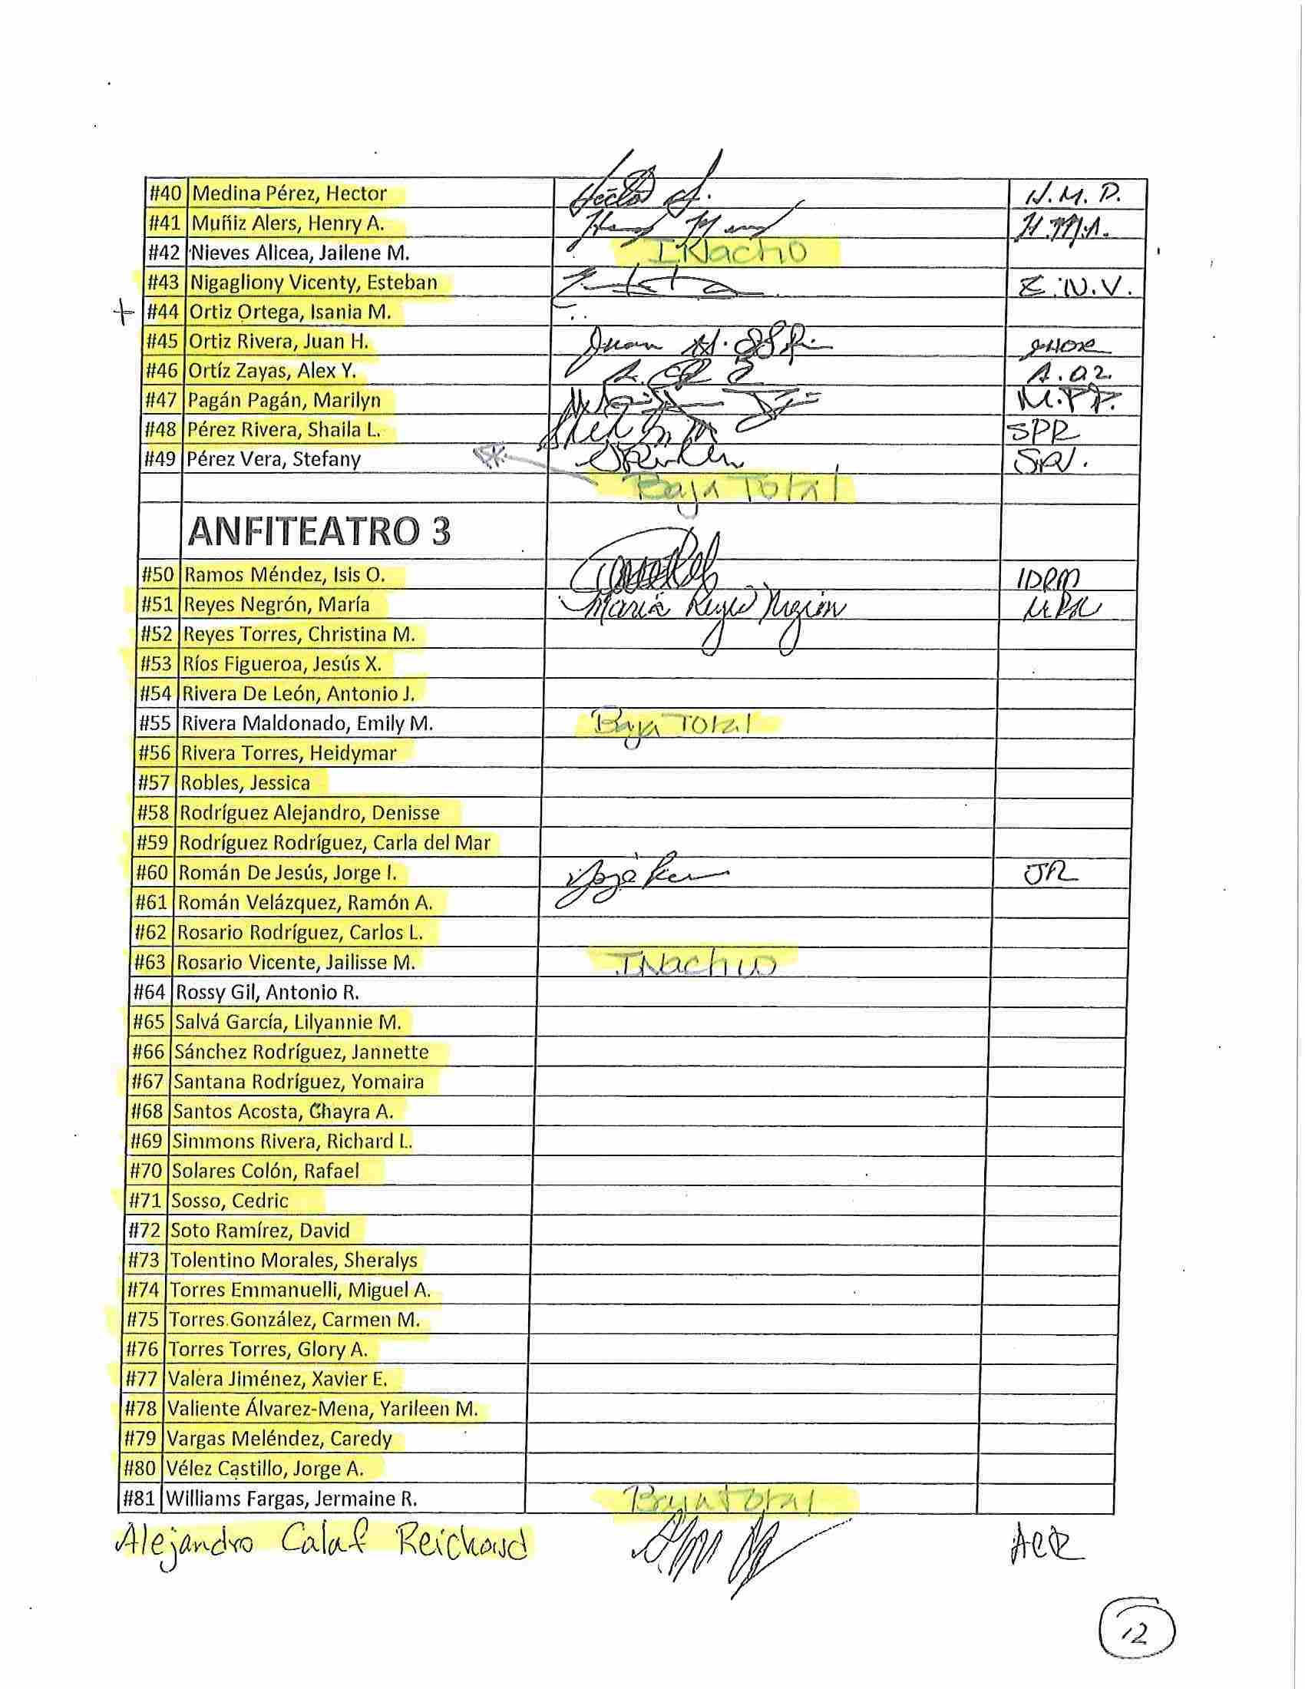
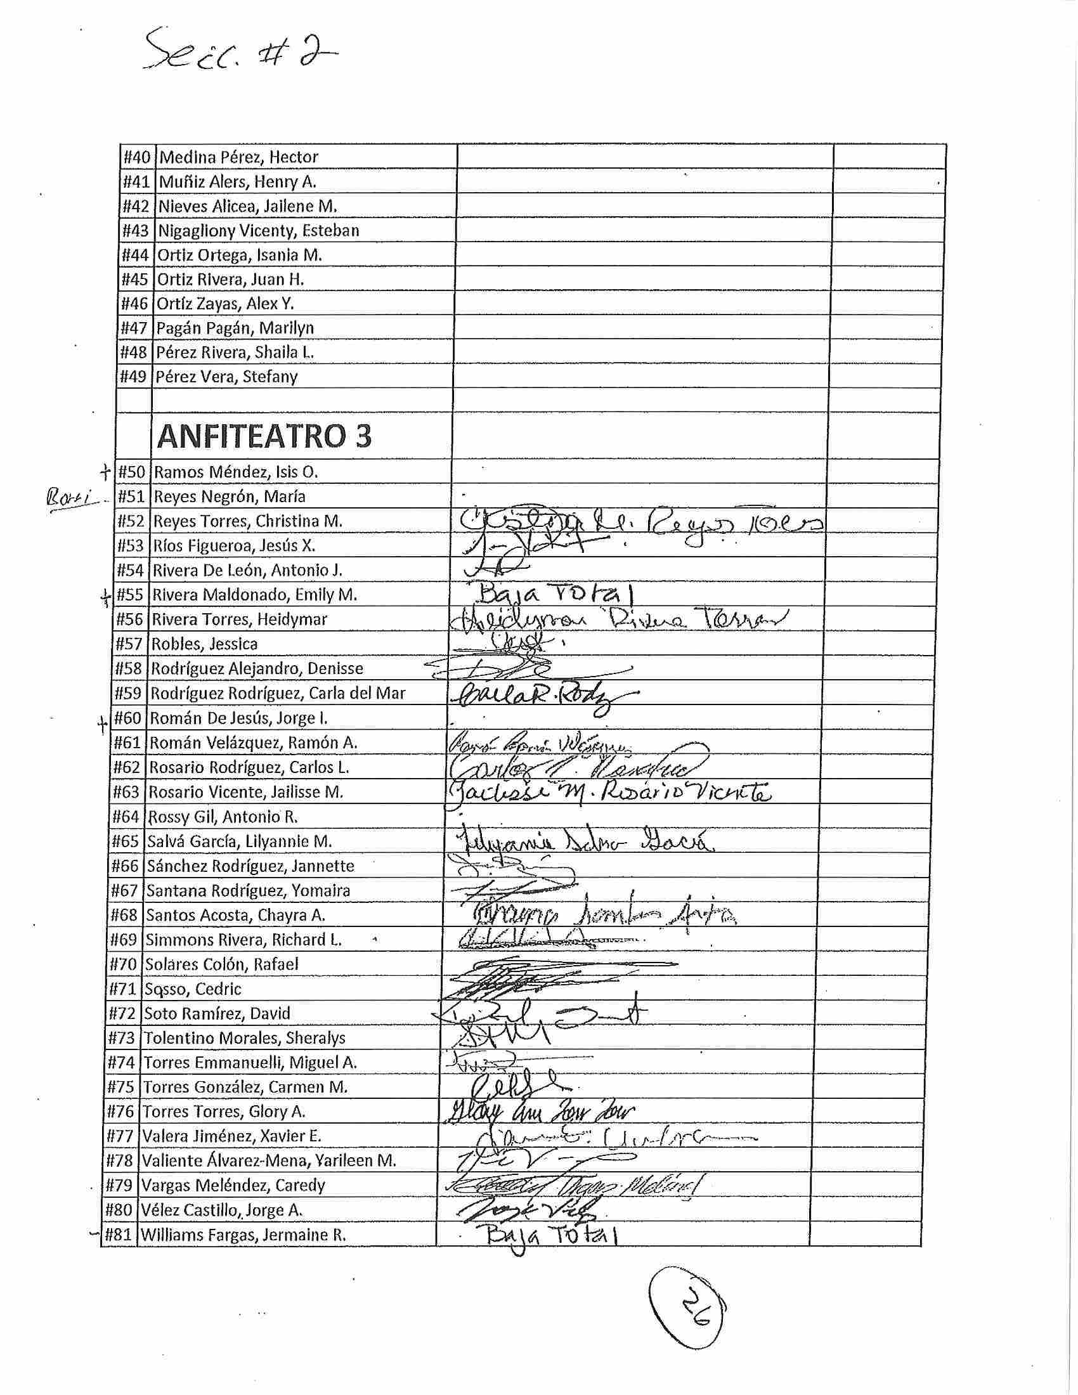

Appendix E
Impacto del uso de drogas y alcohol en la admisión y práctica de la abogacía
(Alcohol and Drug Consumption and its Consequences for Admition to the Bar and the Practice of Law)
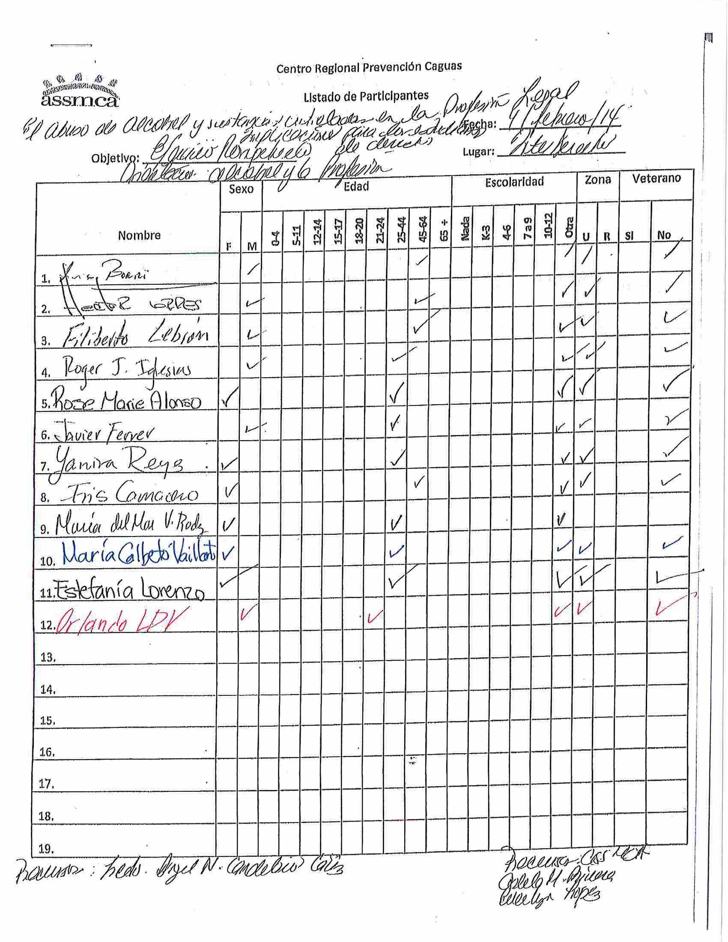

Appendix F

